|  |  |  |  |  |  |  |
| --- | --- | --- | --- | --- | --- | --- |
| **Mehran University of Engineering & Technology,**  **Jamshoro** | |  | **Subject** | | | |
| **Web Technology** | | | |
| **Department of:**  **Bachelor of Science Computer Science** | | **Year** | **2nd** | **Semester** | **3rd** |
| **Roll No:** | **20BSCS043** | **Batch** | **20BSCS** | **Duration** | **3 Hours** |

**PRACTICAL # 9**

**TO PRACTICE THE CASCADING STYLE SHEETS (CSS) EFFECTS ON HTML PAGES**

**Task # 1:** Type a paragraph in the HTML page with style.

**Code:**

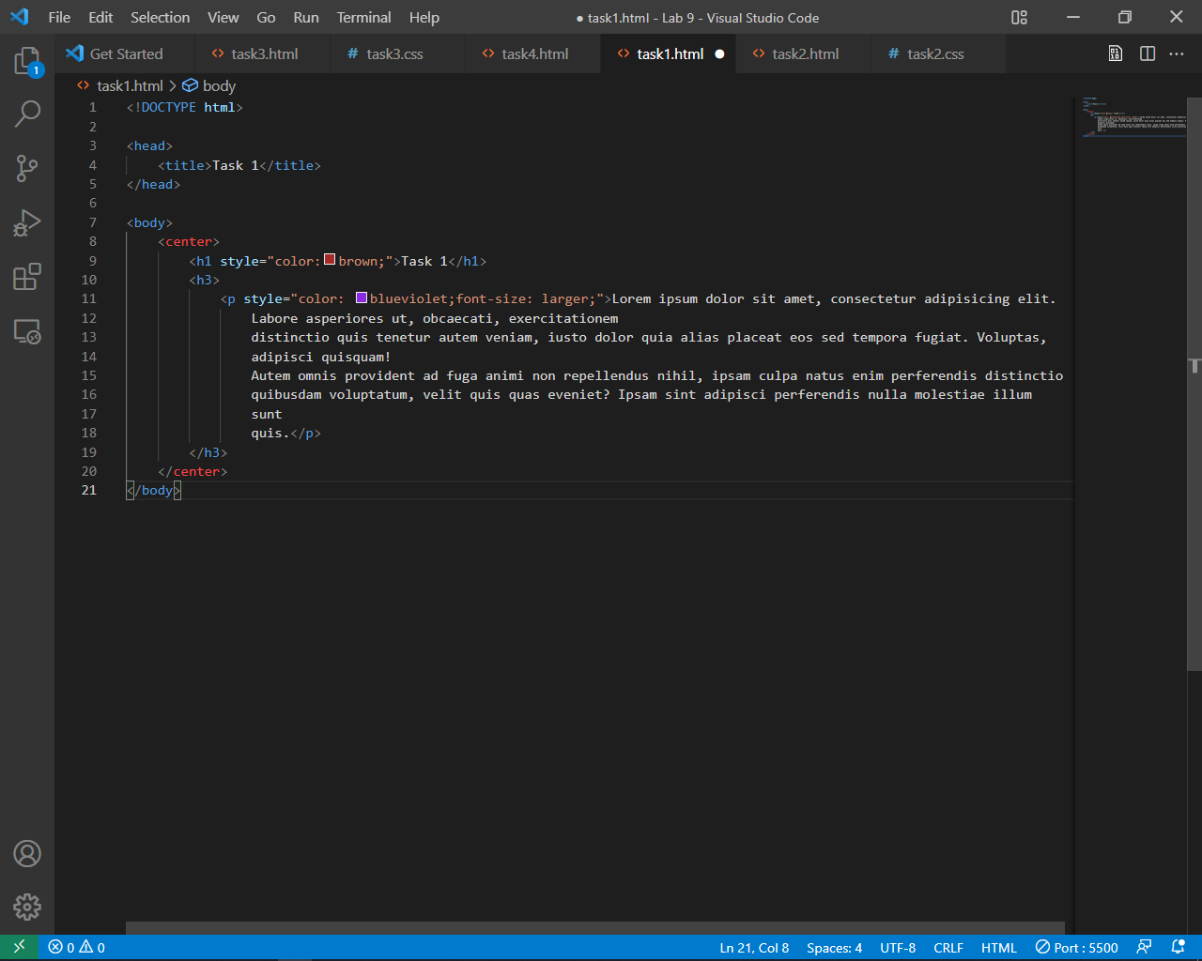

**Output:**

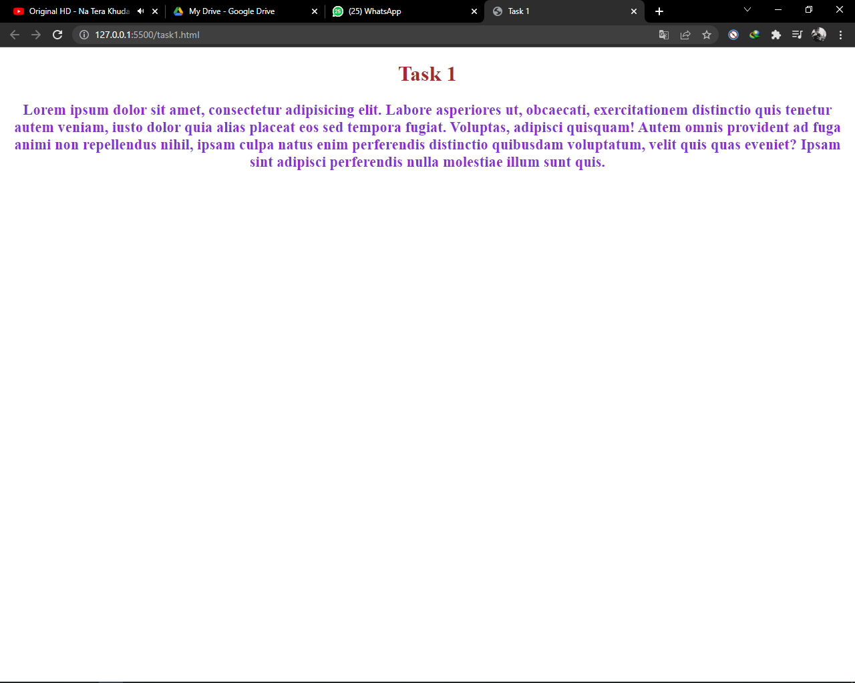

**Task # 2:** Create h3 style (with no leading dot), existing sheet

* Font= Arial, Helvetica, sans serif

• Font size= 24 px

• Font color red, weight bold or bolder

**Code:**

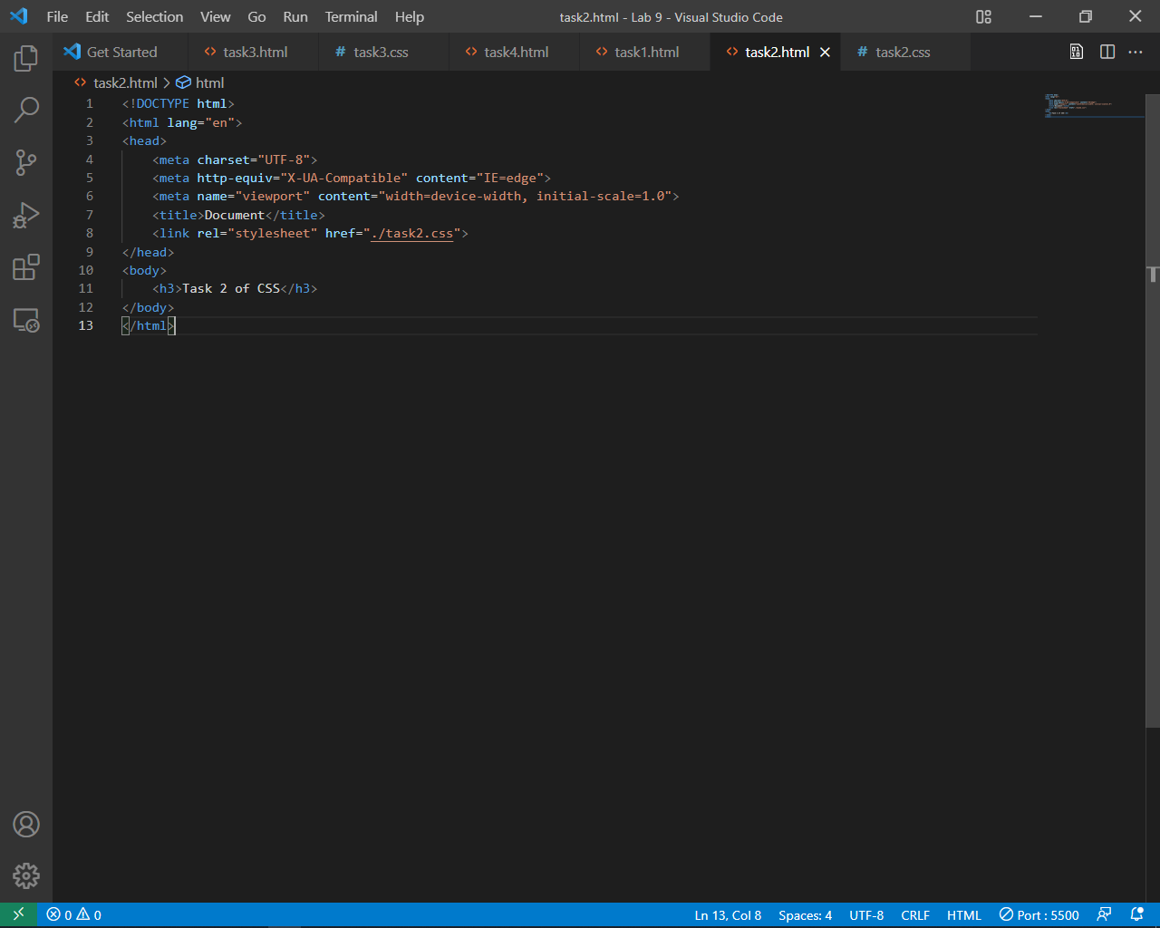

**Output:**

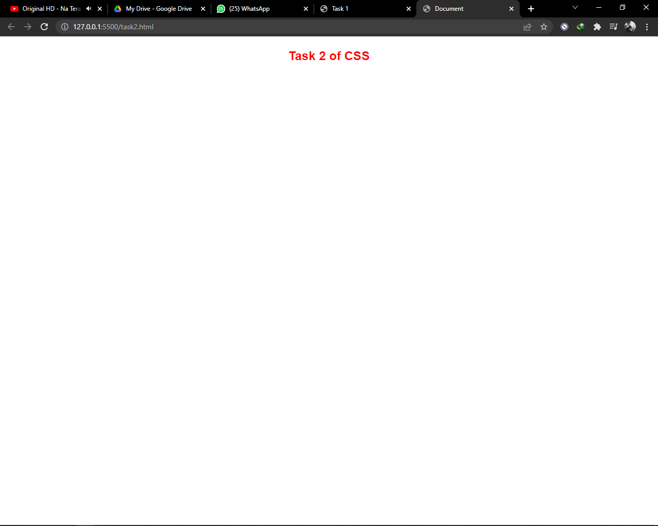

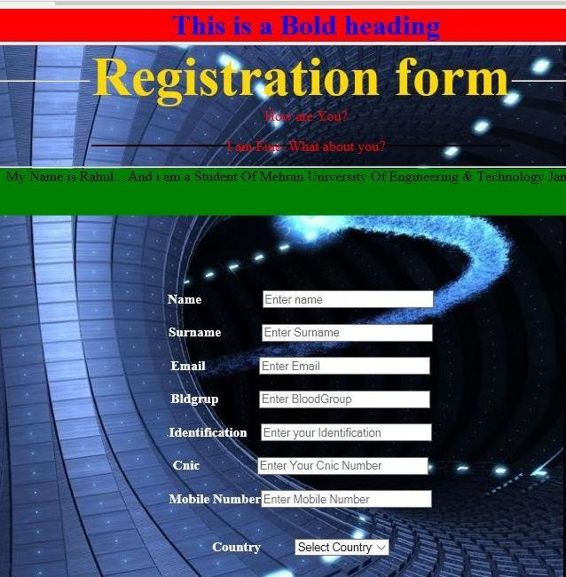**Task #3:** Create HTML form use different input fields apply External CSS

**Code:**

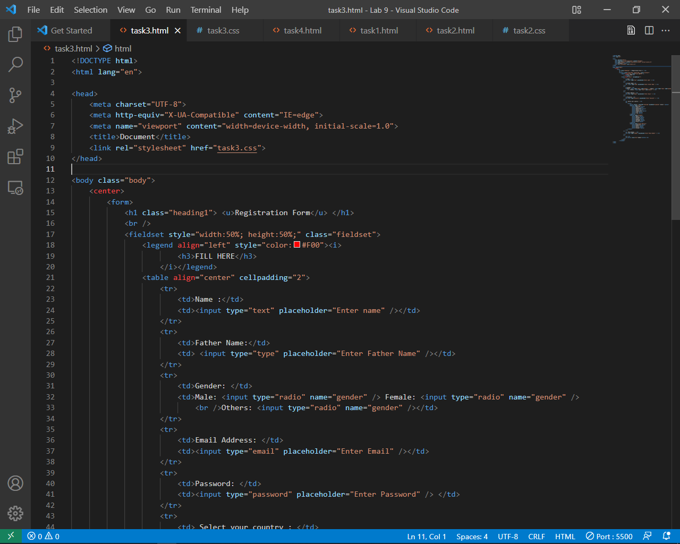

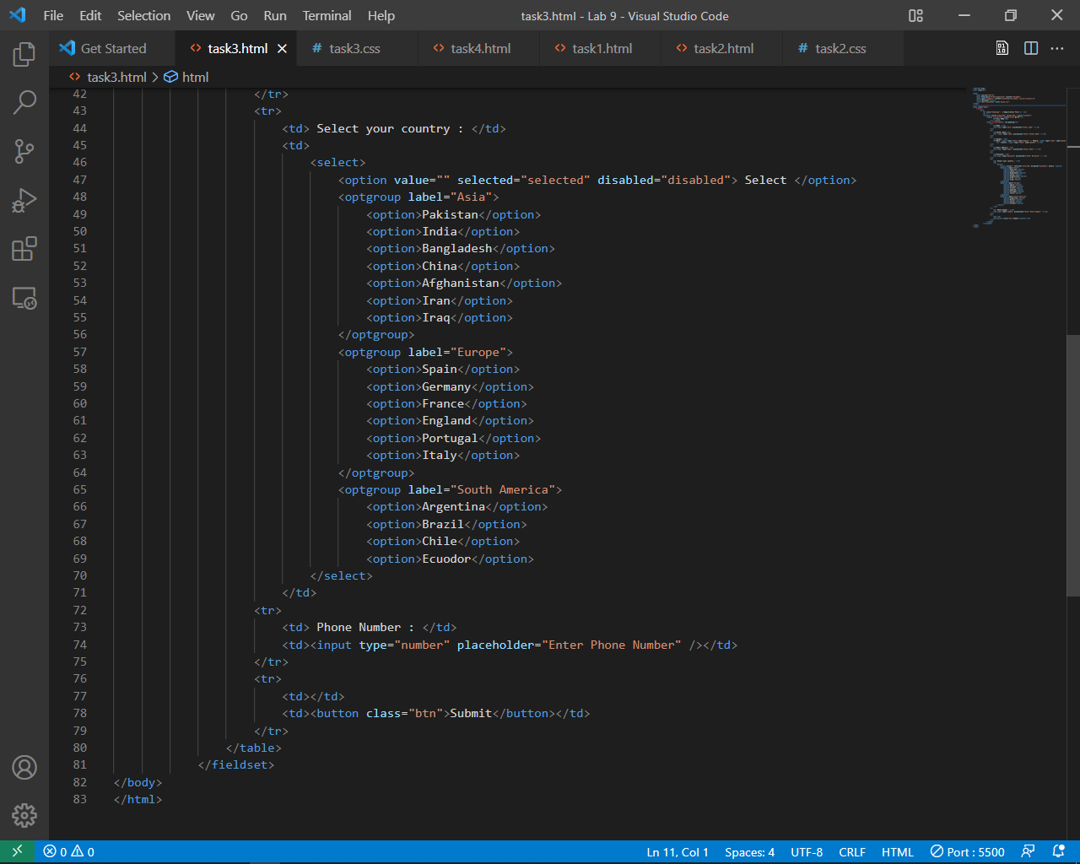

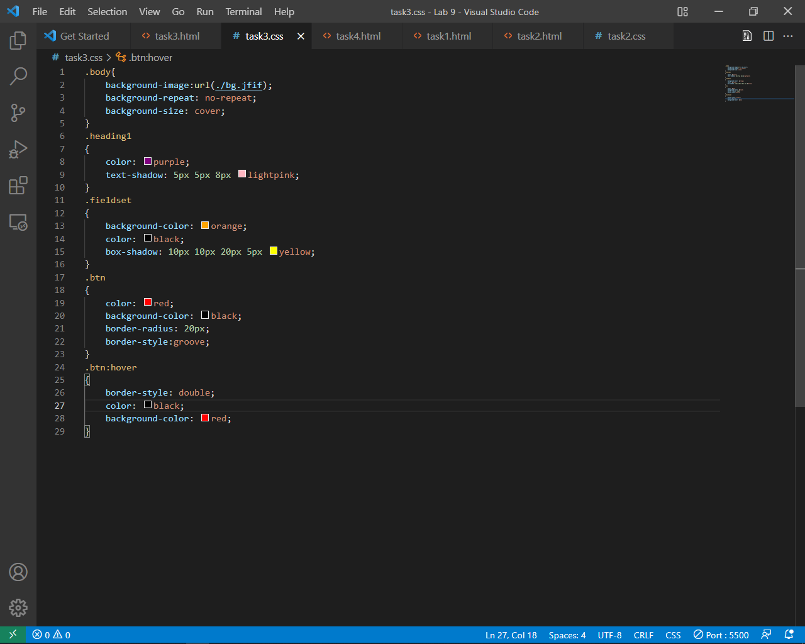

**Output:**

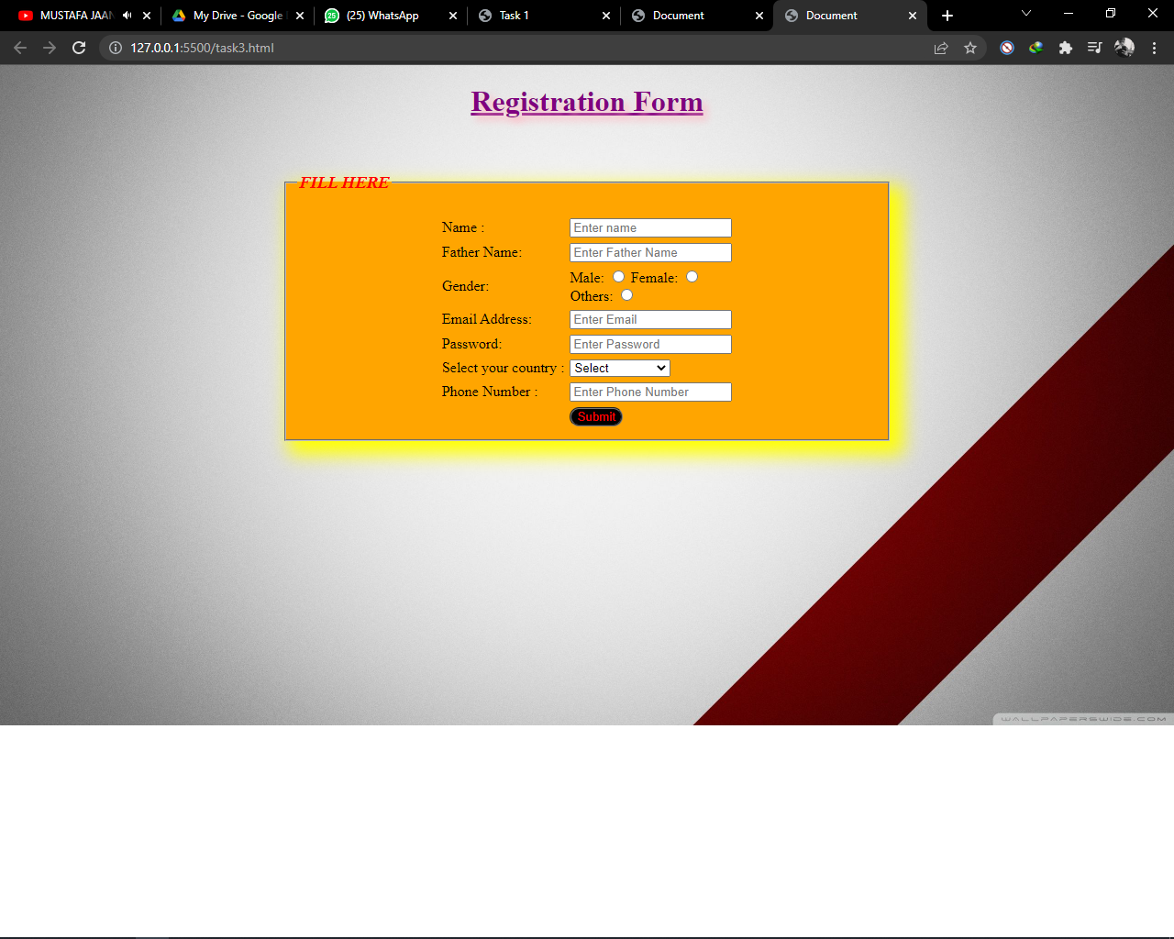

**Task# 4:** Make a Zebra Crossing Table using internal CSS as shown below

|  |  |  |
| --- | --- | --- |
| **Id** | **Name** | **Subject** |
| 1001 | Asghar | Physics |
| 1002 | Susheel | Economics |
| 1003 | Shahzad | Chemistry |
| 1004 | Rameez | Zoology |
| 1004 | Paras | Math |
| 1004 | Sonu | Botany |
|  |  |  |
|  |  |  |

**Code:**

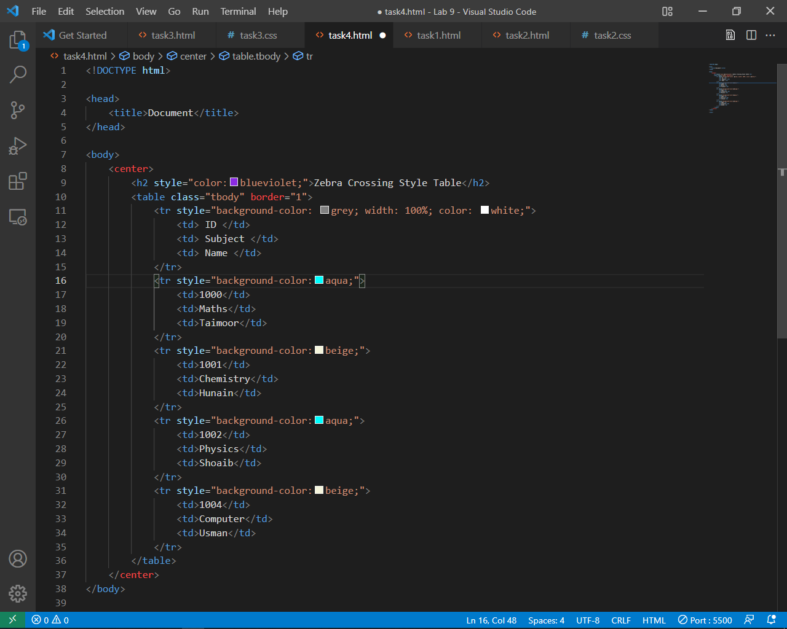

**Output:**

